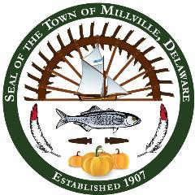

**2025 Holiday Schedule**

Millville Town Hall will be closed for the following holidays.

|  |  |
| --- | --- |
| New Year’s Day | Wednesday, January 1, 2025 |
| Martin Luther King Jr. Day | Monday, January 20, 2025 |
| President’s Day | Monday, February 17, 2025 |
| Good Friday | Friday, April 18, 2025 |
| Memorial Day | Monday, May 26, 2025 |
| Juneteenth | Thursday, June 19, 2025 |
| Independence Day | Friday, July 4, 2025 |
| Labor Day | Monday, September 1, 2025 |
| Veteran’s Day | Tuesday, November 11, 2025 |
| Thanksgiving Day and the Day after | Thursday & Friday  November 27 & 28, 2025 |
| Christmas Eve | Wednesday, December 24, 2025 |
| Christmas Day | Thursday, December 25, 2025 |

This is a tentative schedule and is subject to change if deemed necessary.