Traffic Contact Totals for Millville Contract Policing Patrols

46 Total Traffic Stops; 7 Traffic Warnings and 45 Traffic Charges issued. 28 of the summonses issued were for cell phone violations. During the month, one of the assignments was utilized to assist with the Whimsical Woods event at Lords Landscaping and Troop 4 provided for another assignment to support the community event.

Crime Mapping - www.dsp.delaware.gov
Public has access to this site for greater details if needed.

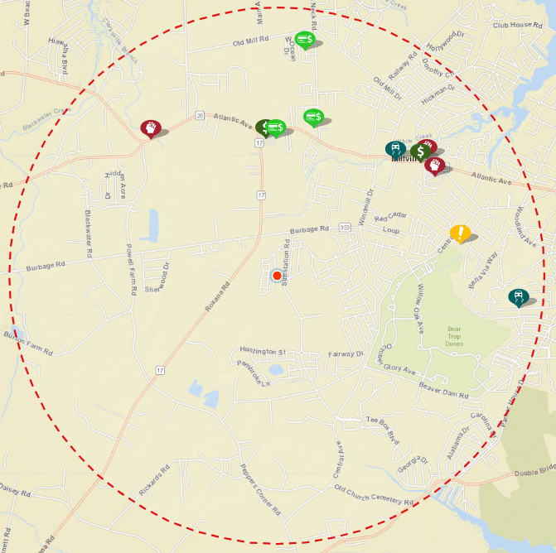

Crime Categories

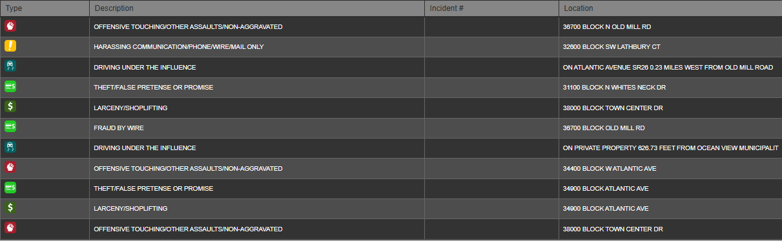

Crime Dates
